Hands on Azure

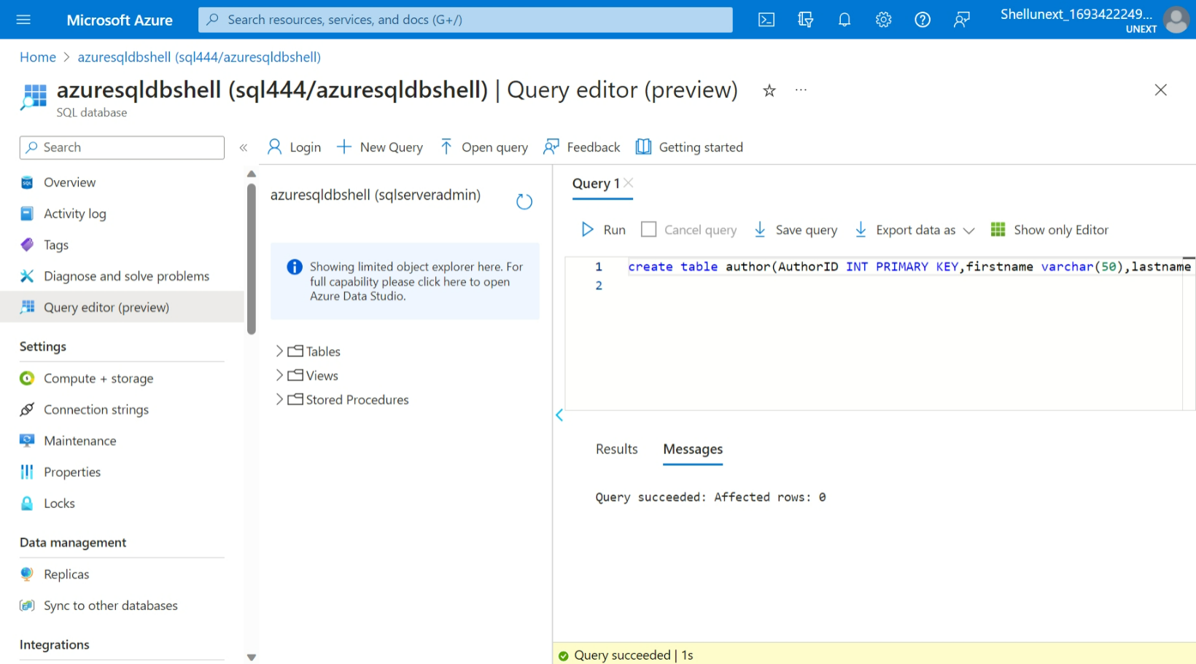

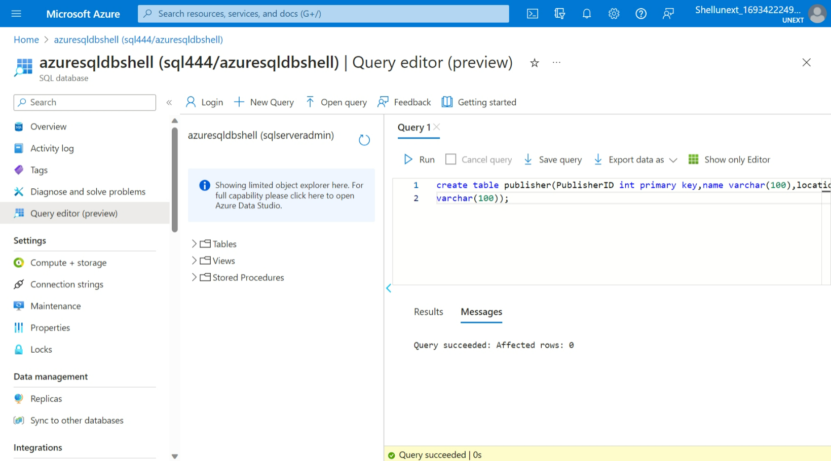

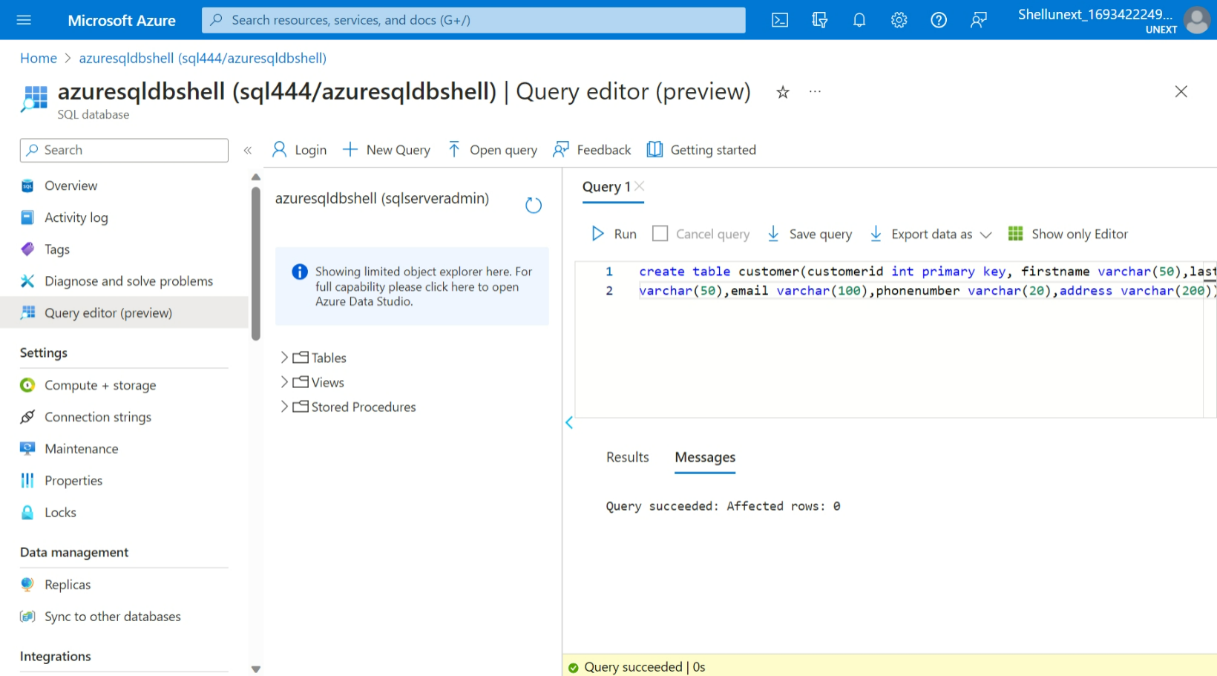

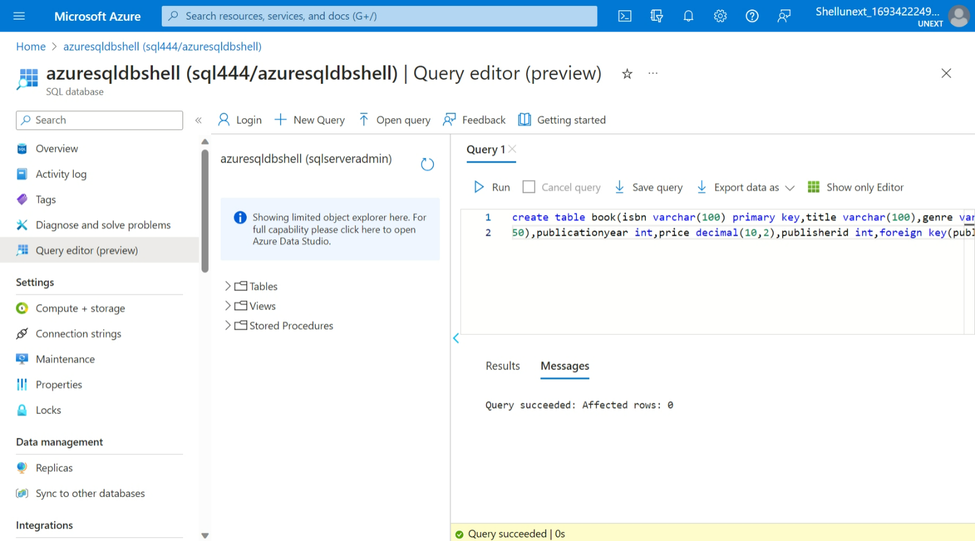 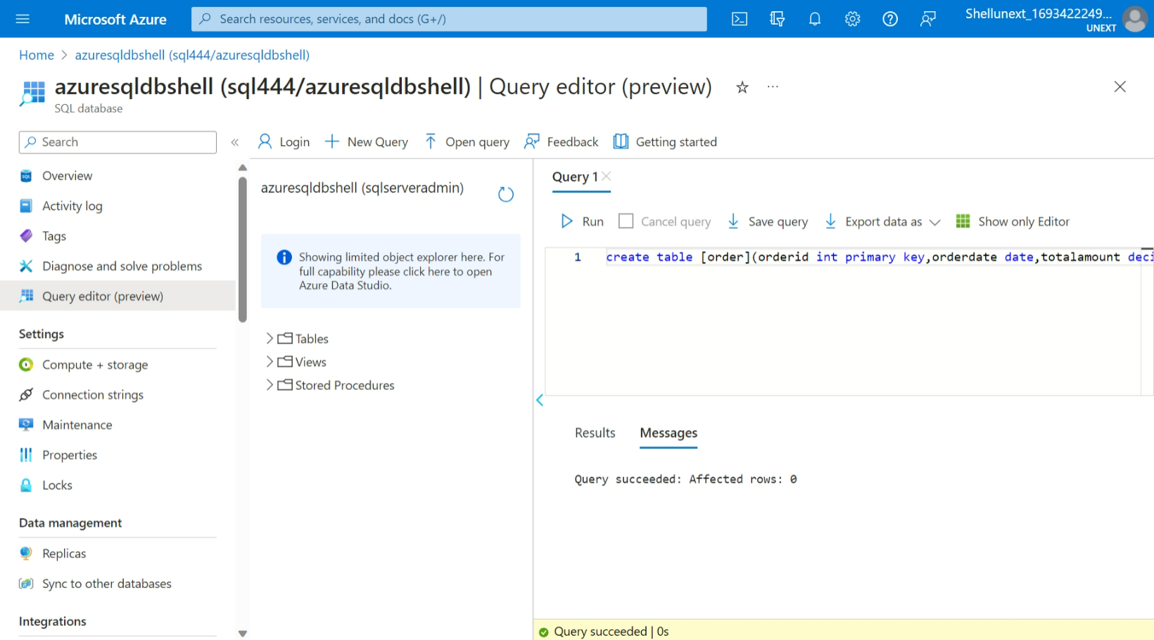

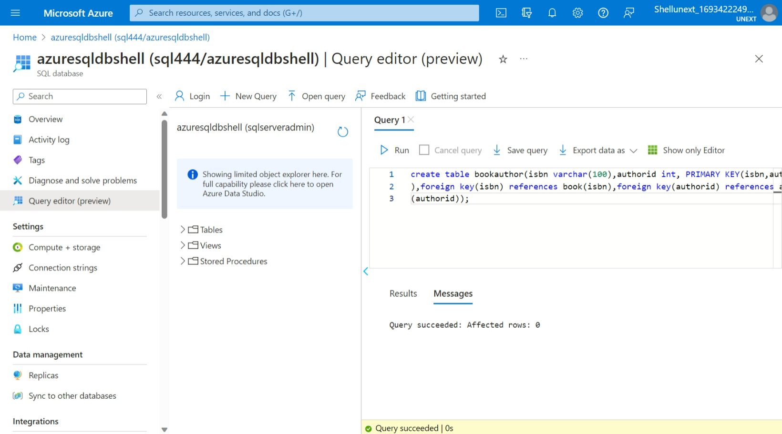 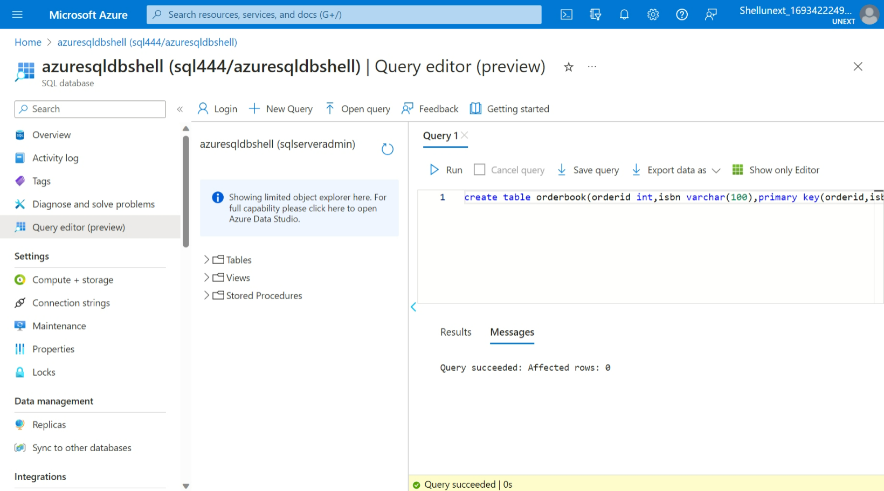 insert into author(AuthorId,firstname,lastname,dateofbirth,nationality)

values

(1,'J.K','Rowling','1965-07-31','British'),

(2,'George','Orwell','1903-06-25','British')

select \* from author;

insert into publisher(PublisherID,Name,Location) values(1,'Penguin Books','London

'),(2,'HarperCollins','New York');

select \* from publisher;

insert into customer(customerid,firstname,lastname,email,phonenumber,address) val

ues(1,'John','Doe','john.doe@example.com','123-456-

7890','123 Main St'),(2,'Jane','Smith','jane.smith@gmail.com','987-654-

3210','456 Elm St');

select \* from customer;

insert into book(isbn,title,genre,publicationyear,price,publisherid) values('978-

0-553-21311-0','Harry Potter And Sorcers stone','Fantasy',1977,19.99,1),('978-0-

452-28423-4','1984','Dystopian',1949,12.99,2);

select \* from book;

insert into [order](orderid,orderdate,totalamount,customerid) values(1,'2023-08-

01',33.98,1),(2,'2023-08-15',12.99,2);

select \* from [order];

insert into bookauthor(isbn,authorid) values('978-0-553-21311-0',1),('978-0-452-

28423-4',2);

select \* from bookauthor;

insert into orderbook(orderid,isbn) values(1,'978-0-553-21311-0'),(2,'978-0-452-

28423-4');

select \* from orderbook;

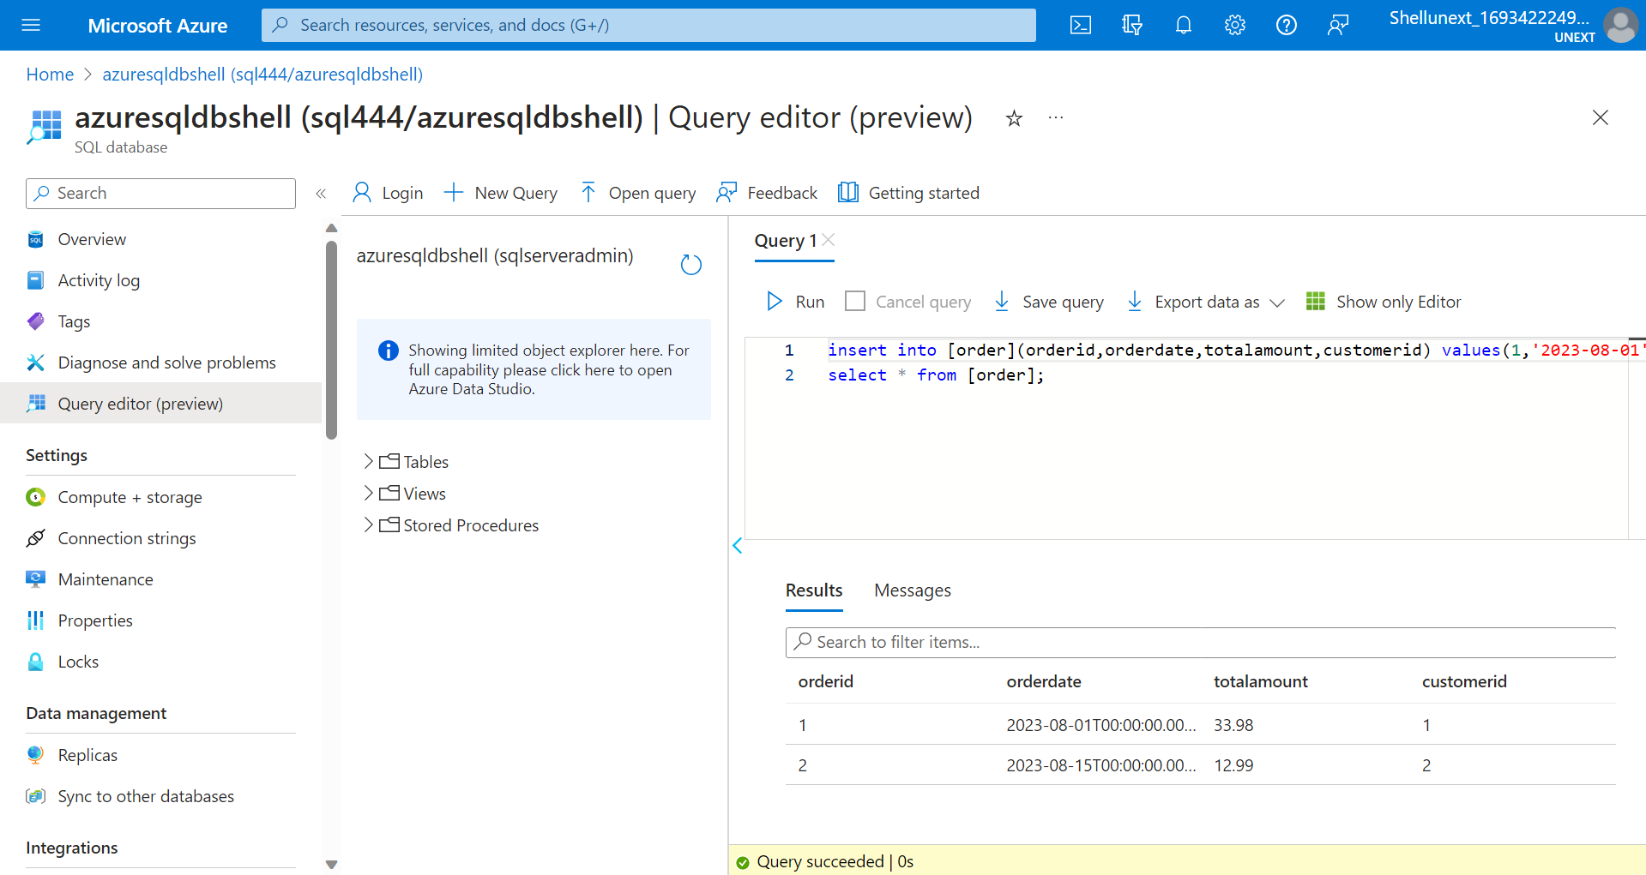

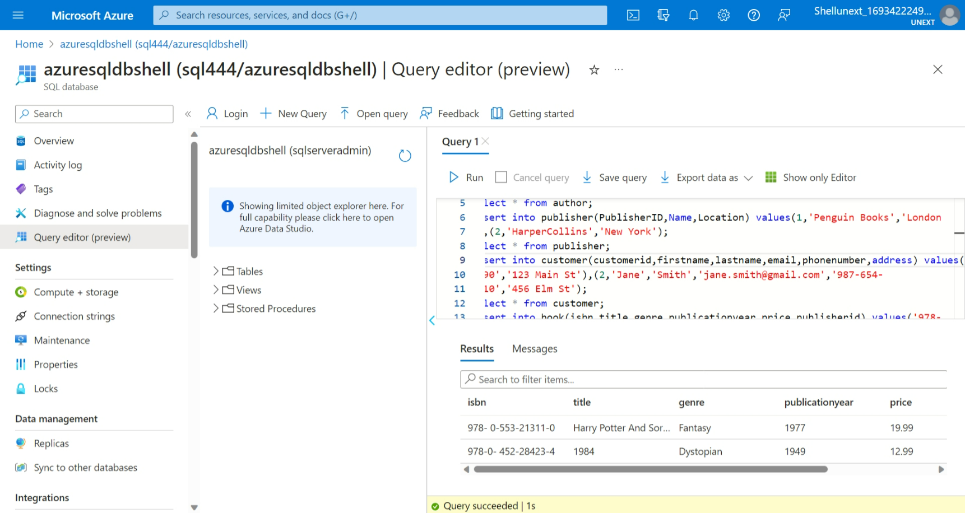 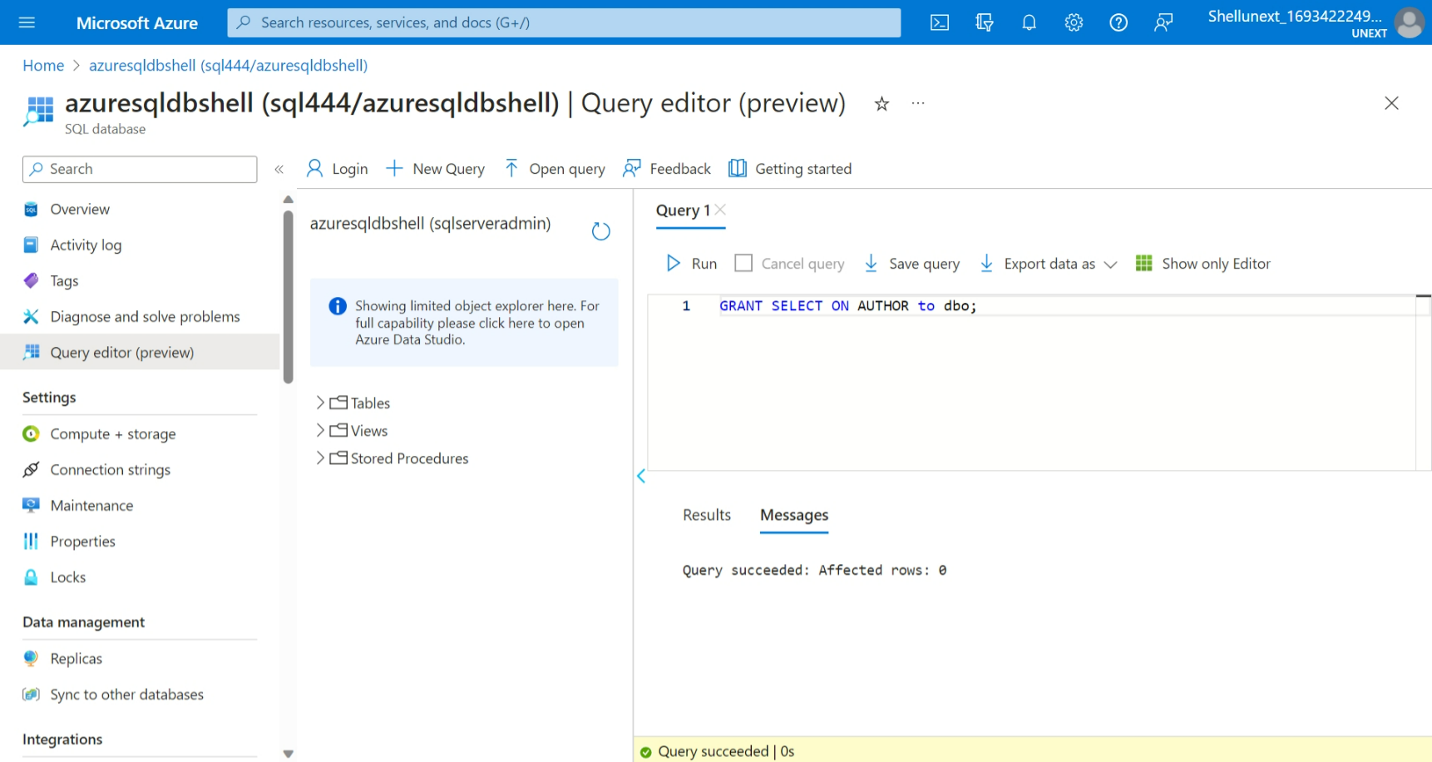 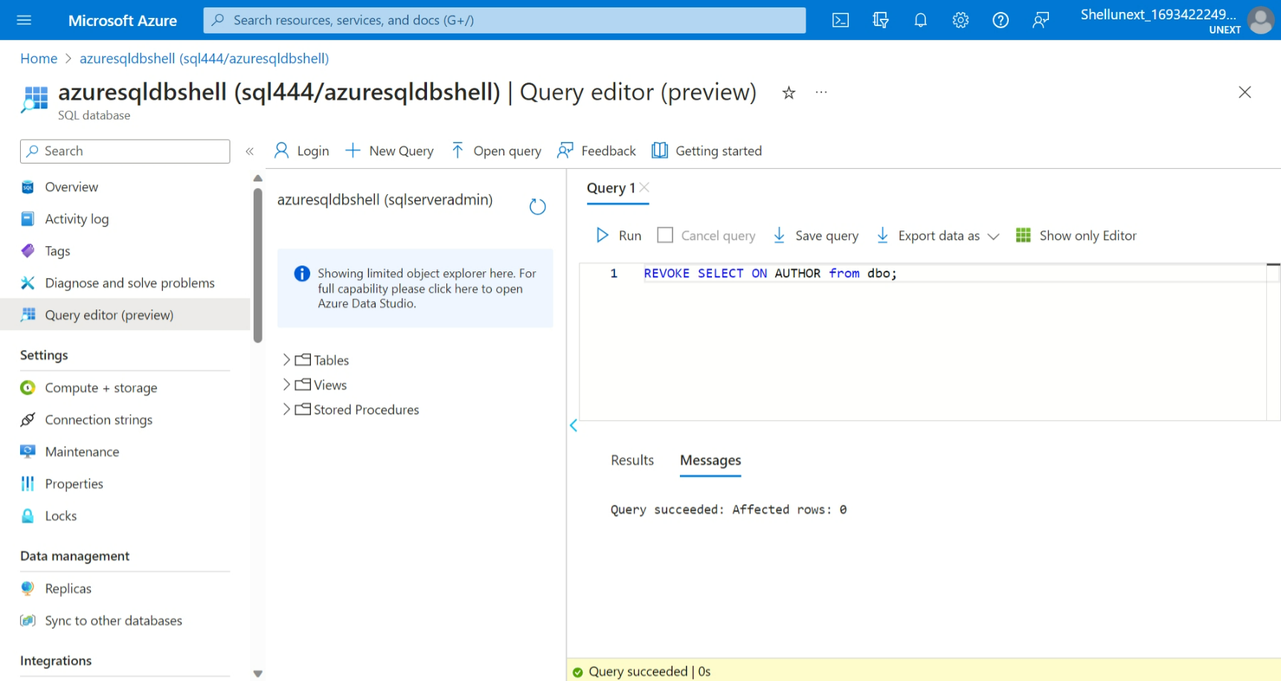 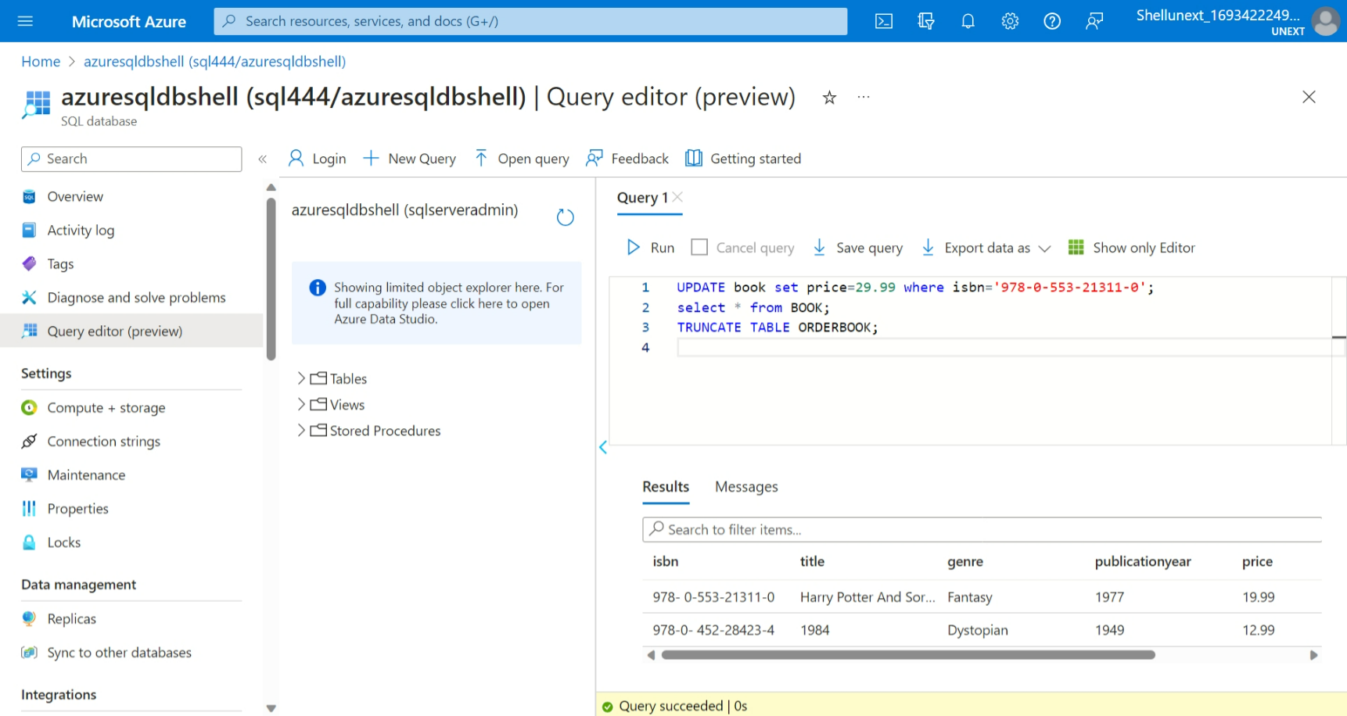 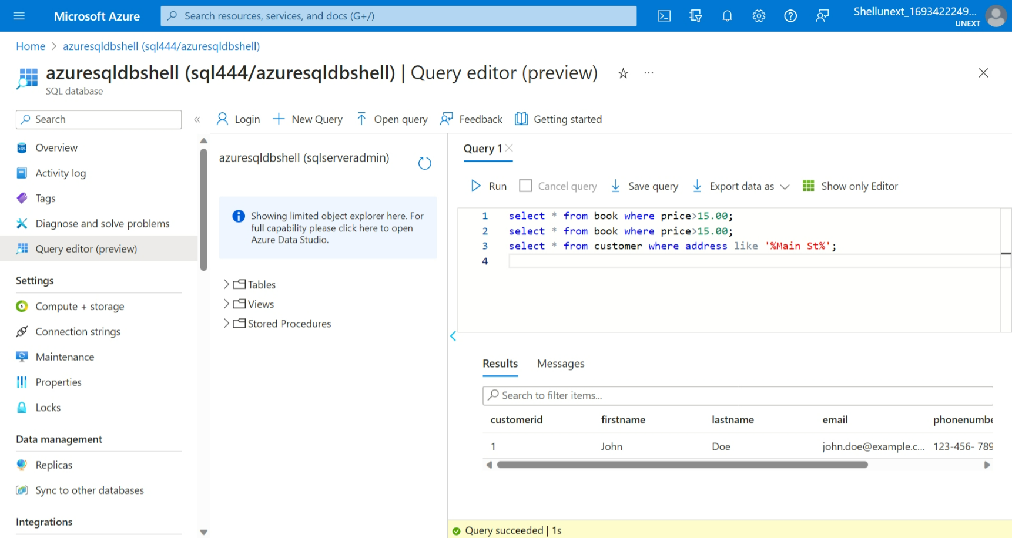 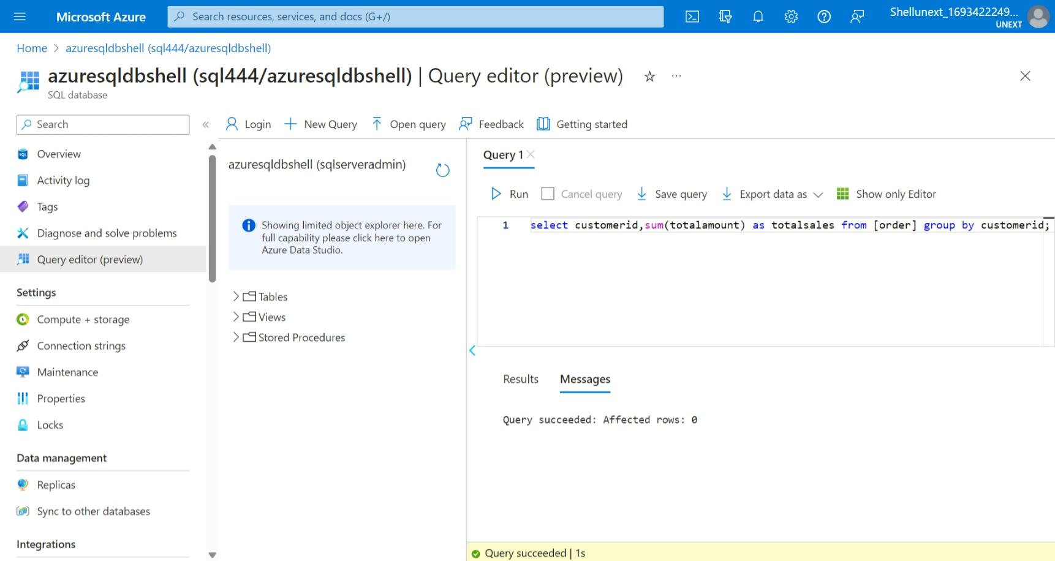 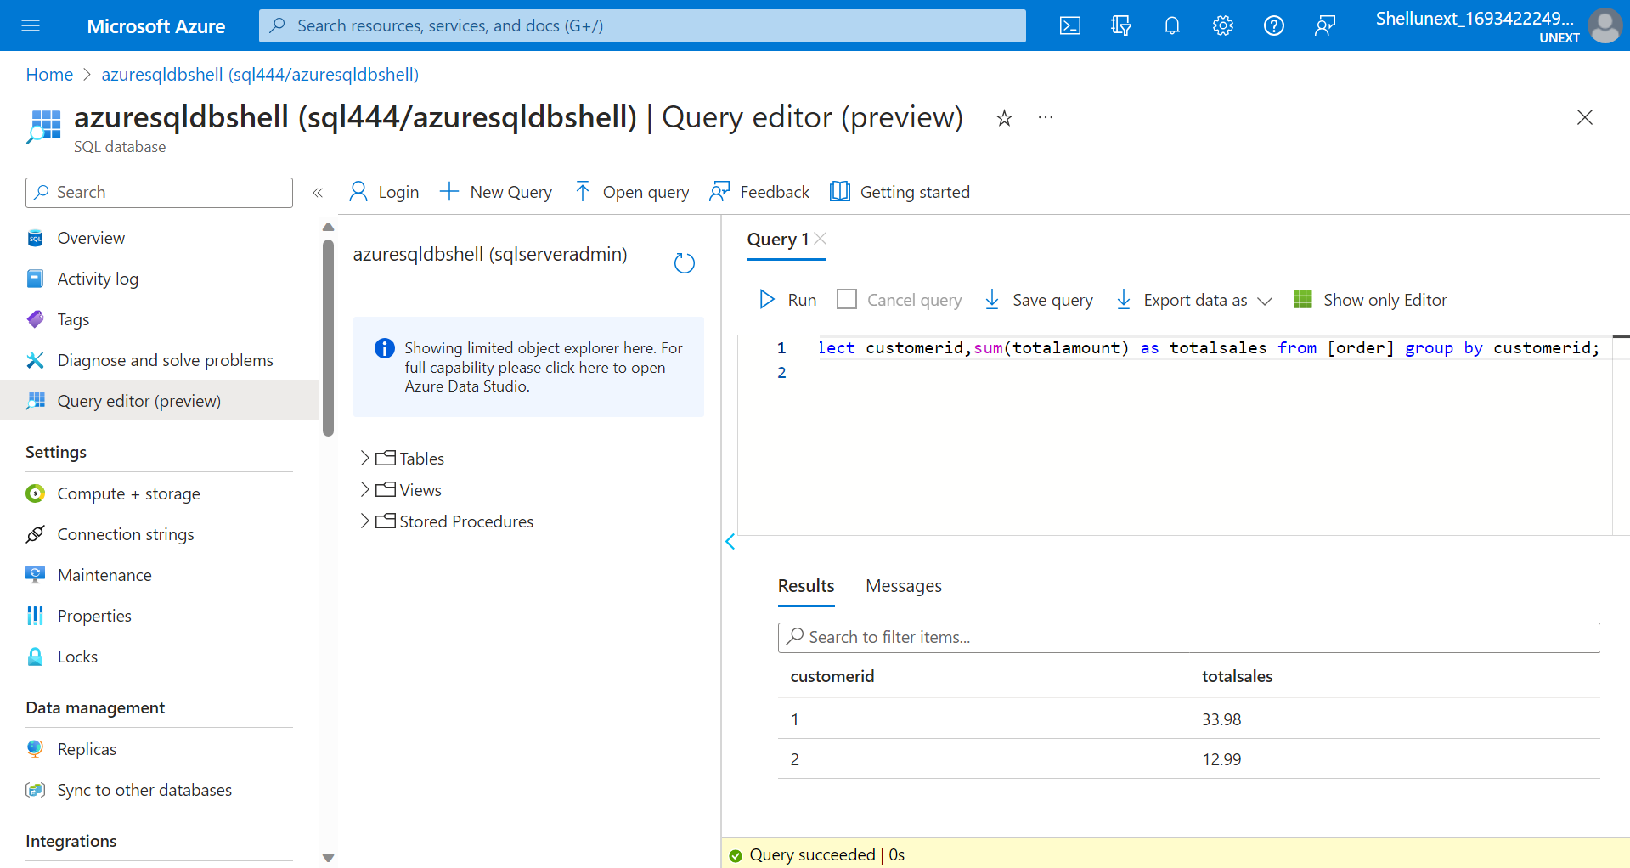 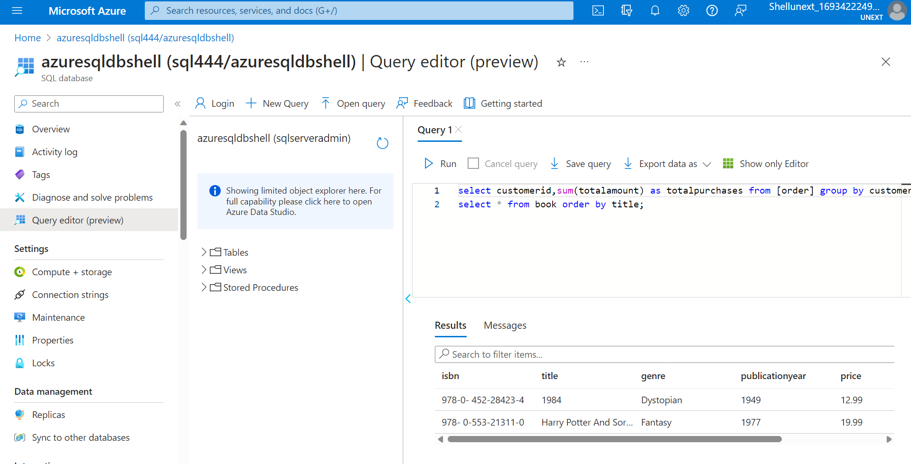

TEST 1:

CREATE TABLE AND INSERT VALUES

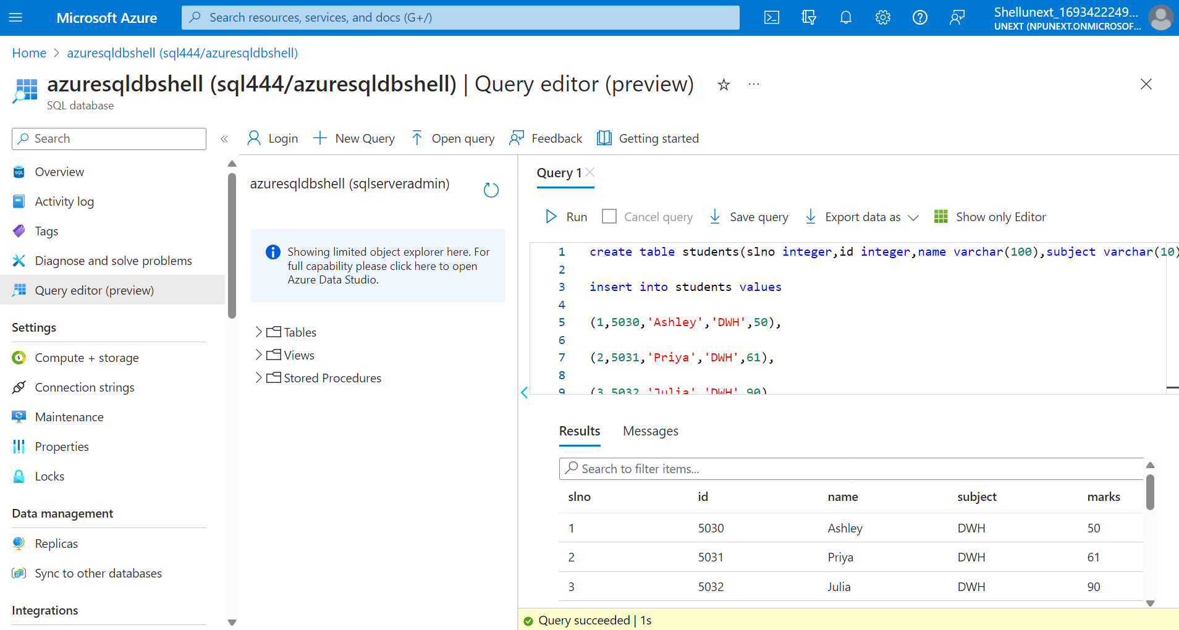

create table students(slno integer,id integer,name varchar(100),subject varchar(10),marks integer);

insert into students values

(1,5030,'Ashley','DWH',50),

(2,5031,'Priya','DWH',61),

(3,5032,'Julia','DWH',90),

(4,5033,'Don','DWH',50),

(5,5034,'Bob','DWH',65);

insert into students values

(6,5030,'Ashley','SQL',75),

(7,5031,'Priya','SQL',80),

(8,5032,'Julia','SQL',40),

(9,5033,'Don','SQL',88),

(10,5034,'Bob','SQL',92);

insert into students values

(11,5030,'Ashley','Azure',95),

(12,5031,'Priya','Azure',45),

(13,5032,'Julia','Azure',85),

(14,5033,'Don','Azure',57),

(15,5034,'Bob','Azure',44);

select \* from students;